**PROJECT REPORT**

**ELC-2023**

**Real-Time Application based on Computer Vision**

Thapar institute of engineering and technology (TIET).

ON THE TOPIC:

AIR CANVAS

(Using OpenCV python)

Presented By:

Shreya Agrawal 102217170

Arshdeep Kaur 102217192

**AIR CANVAS (Using OpenCV python programming):**

**Introduction**

Writing in Air is one of the most fascinating and challenging experience.

The traditional method of writing includes pen and paper. The essential aim of this air canvas is building hand gesture recognition system to write digitally. It will use computer vision to trace the path of the finger. The generated text can also be used for various purposes, such as sending messages, emails etc. It will be a powerful means of communication for the deaf.

**Challenges encountered:**

1. Fingertip detection:

Fingertip detection is the major challenge that has been encountered in this project. Identifying and characterising an object such as finger from an RGB image is a great challenge.

1. Lack of pen up and pen down:

Sometimes, Even when fingertip’s entire trajectory is traced, resulting image turn out to be absurd and not recognised by the model.

1. Creating a clear mask of fingertip:

Creating a clear mask of fingertip is one of the problem faced. A lot of impurities in mask were encountered and then handled.

**System and technology used:**

It can be implemented using machine learning and OpenCV using python.

But we have built this project using OpenCV python.

**Algorithm of workflow:**

Writing involves a lot of functionalities. So, the number of actions were involved. The functionalities are:

1. Writing Mode:

In this state, system will trace the fingertip coordinates and stores them.

1. Colour mode:

The user can change the colour of the text among the various available contours.

1. Backspace:

Say if user goes wrong , he/she can erase the whole writing by just clicking on clear all option.

Three windows have been created one for live writing, another for storing the content and third one is mask window:

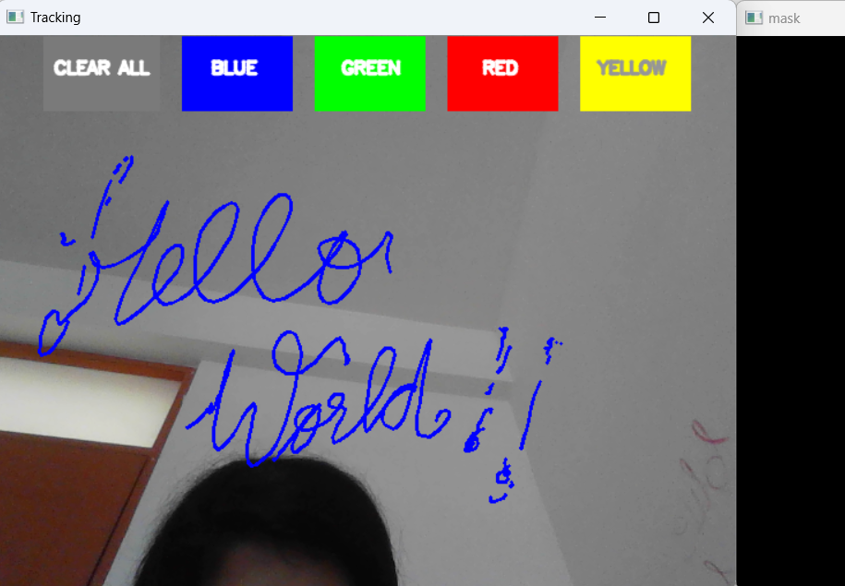

1. Video capture window (capturing the live hand movement and creating a contour on screen)

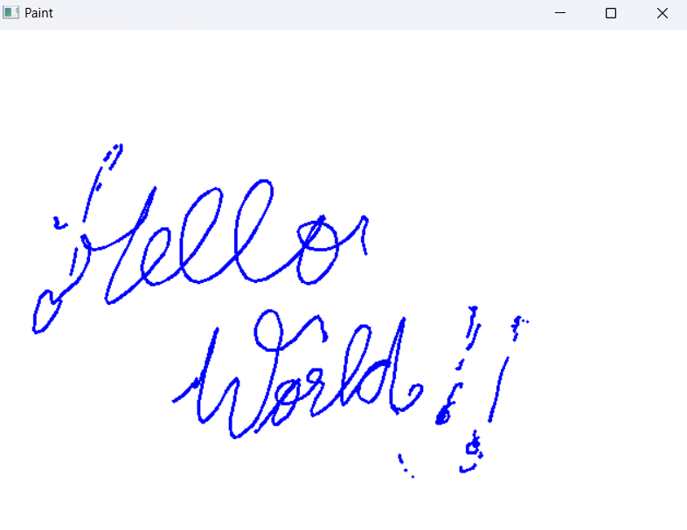

1. All the writings are stored in paint window.

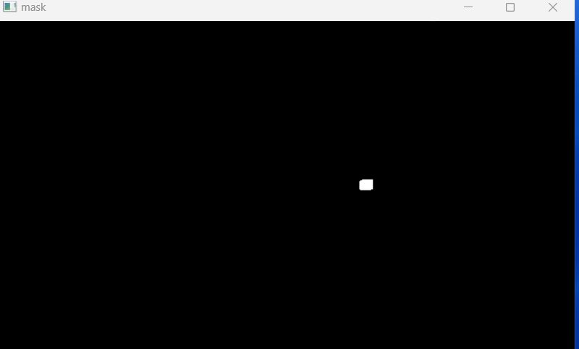

1. Mask window (detecting the fingertip creating a mask of the

same)